# Why You Need SSL to Accept Payments and How to Setup SSL Certificate on HubSpot Website

What makes a great online store? It used to be that mobile optimization, great content, and responsiveness alone were enough.

Well, part of the process that you must accomplish when developing an online store is determining how to secure online experiences of your customers. If you’re new to online stores, you might get confused on SSL certificates as a primary component of the web security process. You may have tons of queries such as: what it is, how it works and more important, how to set it up on your HubSpot website.

In “***Why You Need SSL to Accept Payments and How to Setup SSL Certificate on HubSpot Website***” we break it down for you so that you understand what SSL is, why you need it on your website and how to set it up on your online store. Let’s get started.

## What is SSL?

SSL is an acronym for Secure Sockets Layer. In some instances, it’s called the TSL (Transport Security Layer). SSL is simply a protocol that encrypts transactions between a client application (a browser) and the online store server. Simply put: SSL protects the sensitive information such as credit card details—by making them private and confidential—from being stolen by malicious users over the internet.

SSL uses an encryption algorithm that ensures that each message being exchanged on the web passes integrity test before being transmitted. If the integrity test fails—due to corruption or an unexpected alteration by malicious users—then such a transaction doesn’t proceed to successful conclusion.

For you to enhance the security of online transactions, you should obtain an SSL certificate that’s relevant for that domain. The certificate will apply the encryption algorithms for all the transactions that take place between customers and your online store.

## Why is SSL certificate vital for accepting payments?

As online mercantile, it’s your primary responsibility to ensure that the information being exchanged over your online store—which you collect from your customers—is protected at all costs. Here are reasons why you should protect your customer’s sensitive information such as credit card and personal information:

### #1: Confidential Transactions

The primary objective of any SSL is to transmit sensitive information with an encrypted connection. Your customers must be assured that their private data such as usernames, passwords and credit card numbers are not revealed to malicious attackers while they are making online payments.

### #2: Customer’s Trust

The majority of online shoppers are very choosy when it comes making online payments. Therefore, it’s your duty to convince them their privacy is guaranteed so that they trust your business and your products. An SSL enabled online store improves customer’s trust to your business.

## How to set up an SSL certificate on a HubSpot website

The process of setting up an SSL certificate on a HubSpot website is akin to connecting a domain to HubSpot. However, you’ll be required to incorporate a few basic steps to ensure SSL is enabled on your website. Below are steps that can help you set up an SSL certificate on a HubSpot website:

* Request to have access to the SSL certificate by getting in touch with your Customer Success Manager. You’ll be informed when you have access to the SSL certificate.
* Navigate to your HubSpot’s Domain Manager by clicking **Content**>**Content Settings**. You should see a screenshot similar to the one below:

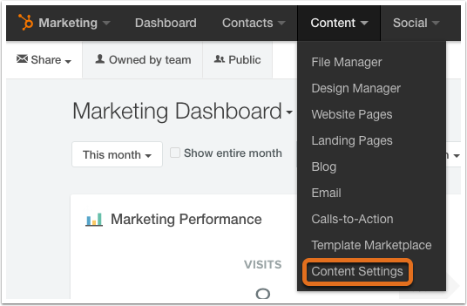

* Locate the “***Content Optimization System Tools***” from the sidebar navigation and click “***Domain Manager.***”

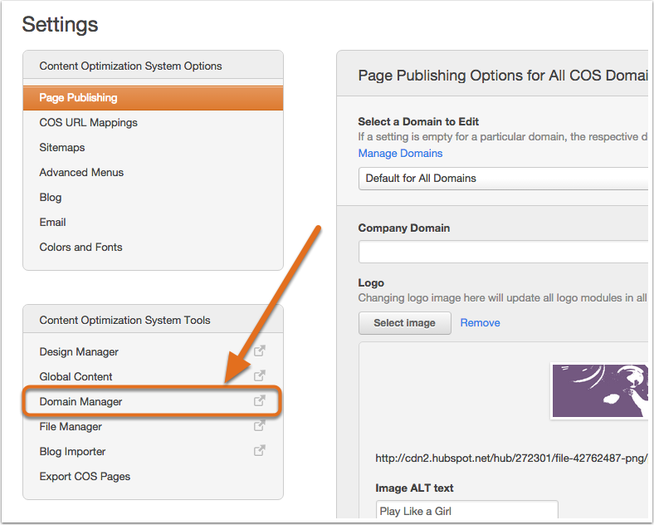

* Type in the sub-domain—of the online store— that you would like to connect to HubSpot. Now note that a different SSL provisioning process is mandatory for each secure domain that you specify.

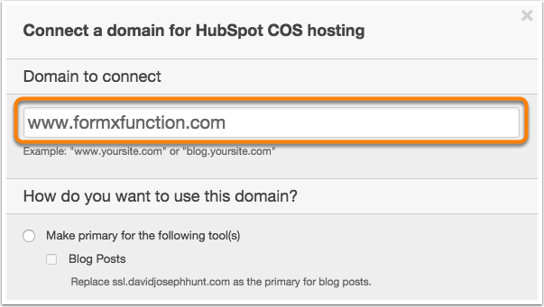

* Tick the “***Enable SSL***” option. You can only view this option if you have an add-on on your website or you have purchased the standalone SSL.

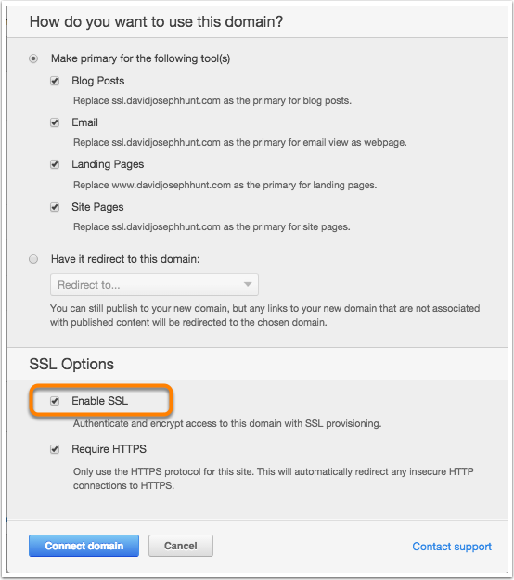

* Click on “***Connect Domain***” after you have selected the content types that you would like to use with SSL for your sub-domain.

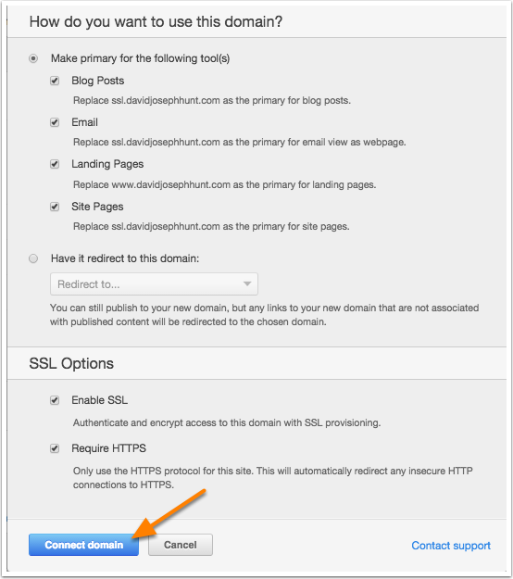

* The provisioning process will start. This requires the generation of an SSL certificate and verification of the domain ownership. If you’re set to start the provisioning process, click on “***Enable SSL***.”

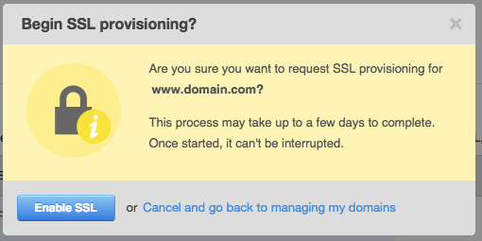

* You should now see a confirmation prompt that the provisioning process has started and is in progress. After this process starts, HubSpot will send you a confirmation message that the process has been initiated.

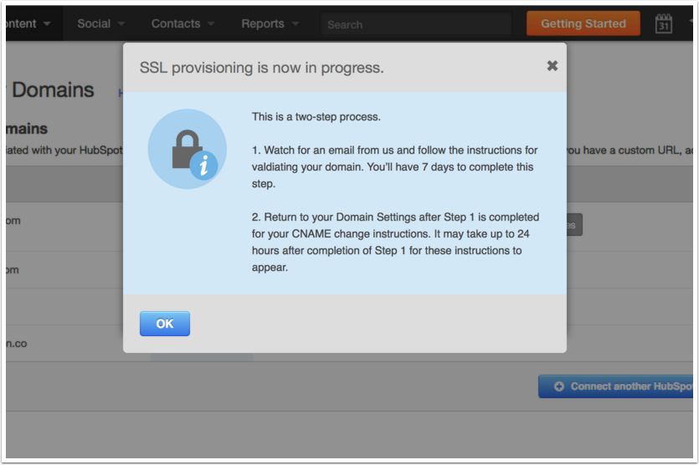

* After adding your domain, you’ll have 7 days to validate that domain with HubSpot to prove the ownership to the certificate. Clicking on the option “**validate your domain**” in the banner at the top of the Domain Manager helps you to validate the domain.

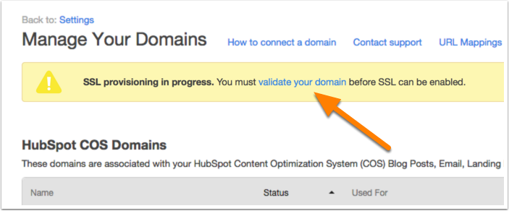

* You can use either “Set up a redirect link” or “create a new page” to validate your domain.

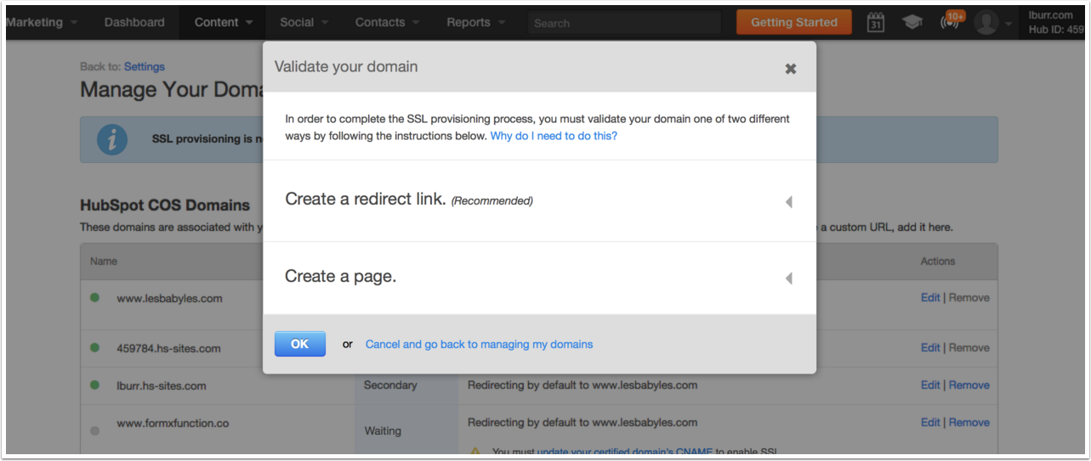

* Now select the content types that you would like to host on your secure domain. Or, you can select the “***redirect this domain to another connected domain***.”
* Once you have verified your domain with the SSL certificate authority, you’ll receive an email from HubSpot. Now go back to the ***Domain Manager***. You will now see a notice that informs you that need to update the CNAME record for the certified domain. Click on that so that you can see your CNAME.

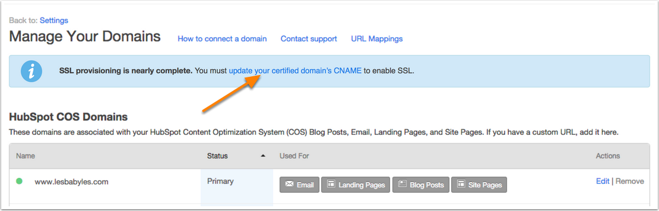

* Now copy your CNAME.

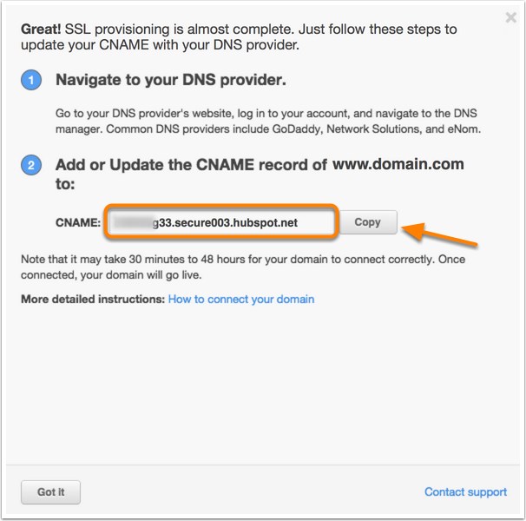

* Update your CNAME within the “nameserver” host.

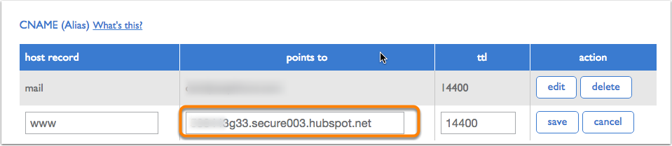

* Verify that the domain is connected after 24-48 hours.

